Mixture of Experts - Experiment 1-7

1. Introduction

Mixture of experts is a class of model, where output is formed by several experts together. By experts, we refer to machine learning models. The outputs of experts are combined by weighted sum assigned by some gating function. We want to answer the question: (1) Can the jointly learned gate and experts outperform the distinctly learned experts with a pre-designed gate, which we think is ideal. (2) If the mixture of experts outperforms a single expert; (3) How the number of experts effect the performance. To answer the questions, we describe the architecture of mixture of experts we use in section 2, describe the dataset in section 3, describe the experiments in section 4, and show results in section 5.

1. Architecture

The mixture of experts will be implemented on a classification task, so the output data will be a vector containing probabilities for each class. The output of mixture of experts is formed by weighted sum of each experts, where the weights are given by a gating network:

Where is the input, is the weight assigned to the expert , and is the output of expert , which has same dimension as output .

We will have different selections of and , depending on what is the aim of each experiment. We describe those selections in following subsections.

2.1 Experts

There are 2 choices for experts: the linear model with softmax output, and the convolutional neural network. We call them linear expert and convolutional expert.

The linear expert is represented by the following equation:

Where is the weight matrix to be learned. The matrix multiplication represents a linearly computed score vector with the number of classes as its size. The score vector is then transformed into probabilities by the softmax-function. The softmax-function is defined as following:

The convolutional expert is defined by following code:

layer = *X*layer = tf.layers.conv2d(layer,64,(3,3), padding='same', activation=tf.nn.relu)  
layer = tf.layers.conv2d(layer,64,(3,3), padding='same', activation=tf.nn.relu)  
layer = tf.layers.flatten(layer)  
layer = tf.layers.dense(layer, 64, tf.nn.relu)  
Y = tf.layers.dense(layer, num_classes, tf.nn.softmax)

2.2 Gating networks

We experiment on 4 choices of gating: no-gate, pre-designed gate, linear gate, and 1-hidden-layer gate.

With no-gate, we set the number of experts to be 1. So, = 1 for the only expert 1 and , which is the same as a model without the mixture of experts.

The pre-designed gates output a one-hot vector for each input. The elements of the one-hot are zeros, except being one on a specific index. The specific index is given explicitly and is equal to the index of the super-label of the input. Because the number of super-labels of a given dataset is fixed, the pre-designed gate has always a fixed number of experts on that dataset. The dataset and super-labels will be covered in next section.

The linear gate is the softmax output of a linear model with the dimension of the number of experts. The linear gate is represented by following equation:

where is the weight matrix to be learned via the back-propagation algorithm.

The 1-hidden-layer gate looks like this:

layer = tf.layers.flatten(X)  
layer = tf.layers.dense(layer,64,tf.nn.relu)  
Gate = tf.layers.dense(layer, num_experts, tf.nn.softmax)

1. Dataset

Depending on experiment, we will use 2 datasets: mixture of datasets and cifar-100.

The mixture of datasets is a combination of mnist and cifar-10. The mnist are images of handwritten digits, with 60000 training images of size (28,28,1) and 10000 test images. The cifar-10 are images of objects. It is more complex to classify than mnist. It contains 50000 training images of size (32,32,3) and 10000 test images. Both mnist and cifar-10 have 10 classes, so the combined dataset will have 20 classes in total, where the first 10 classes are from mnist and the second 10 classes are from cifar-10. The number of mnist images of different classes are different, and all cifar-10 classes have same number of images. All Images from both datasets are resized to 32x32 and then gray-scaled to a single color-channel, so the mixture of datasets have 110000 training images of size (32, 32, 1) and 20000 test images.

The cifar-100 is a dataset containing images of objects. The sizes of images are (32,32,3), and there are 50000 training and 10000 testing images. There are 100 classes with same number of images. The 100 classes are grouped into 20 super-classes, each contains 5 basic classes.

3.1 super-labels and pre-designed gate

To use the pre-designed gate, we must define the super-labels of each image in datasets.

For the mixture of datasets, we let the super-label of an image be the source dataset. Then the predesigned gate is , and it always have 2 experts, each expert is has the classification task on the source dataset.

The cifar-100 dataset has already 20 super-classes. So, the pre-designed gate on cifar-100 will have always 20 experts, where each expert has a 5-class classification task.

The labels of cifar-100 are showed in Figure 1 and super-labels are in Figure 2. They are not grouped by indices in original data.

|  |  |  |  |  |  |  |  |  |  |
| --- | --- | --- | --- | --- | --- | --- | --- | --- | --- |
| Index | Label | Index | Label | Index | Label | Index | Label | Index | Label |
| 0 | apple | 20 | chair | 40 | Lamp | 60 | plain | 80 | squirrel |
| 1 | aquarium_fish | 21 | chimpanzee | 41 | lawn_mower | 61 | plate | 81 | streetcar |
| 2 | baby | 22 | clock | 42 | Leopard | 62 | poppy | 82 | sunflower |
| 3 | bear | 23 | cloud | 43 | Lion | 63 | porcupine | 83 | sweet_pepper |
| 4 | beaver | 24 | cockroach | 44 | Lizard | 64 | possum | 84 | table |
| 5 | bed | 25 | couch | 45 | Lobster | 65 | rabbit | 85 | tank |
| 6 | bee | 26 | crab | 46 | Man | 66 | raccoon | 86 | telephone |
| 7 | beetle | 27 | crocodile | 47 | maple_tree | 67 | ray | 87 | television |
| 8 | bicycle | 28 | cup | 48 | Motorcycle | 68 | road | 88 | tiger |
| 9 | bottle | 29 | dinosaur | 49 | Mountain | 69 | rocket | 89 | tractor |
| 10 | bowl | 30 | dolphin | 50 | Mouse | 70 | rose | 90 | train |
| 11 | boy | 31 | elephant | 51 | Mushroom | 71 | sea | 91 | trout |
| 12 | bridge | 32 | flatfish | 52 | oak_tree | 72 | seal | 92 | tulip |
| 13 | bus | 33 | forest | 53 | Orange | 73 | shark | 93 | turtle |
| 14 | butterfly | 34 | fox | 54 | Orchid | 74 | shrew | 94 | wardrobe |
| 15 | camel | 35 | girl | 55 | Otter | 75 | skunk | 95 | whale |
| 16 | can | 36 | hamster | 56 | palm_tree | 76 | skyscraper | 96 | willow_tree |
| 17 | castle | 37 | house | 57 | Pear | 77 | snail | 97 | wolf |
| 18 | caterpillar | 38 | kangaroo | 58 | pickup_truck | 78 | snake | 98 | woman |
| 19 | cattle | 39 | keyboard | 59 | pine_tree | 79 | spider | 99 | worm |

Figure . Labels of cifar-100

|  |  |  |  |  |  |  |
| --- | --- | --- | --- | --- | --- | --- |
| Index | Super-Label | Basic Labels | | | | |
| 0 | aquatic_mammals | 4 | 30 | 55 | 72 | 95 |
| 1 | fish | 1 | 32 | 67 | 73 | 91 |
| 2 | flowers | 54 | 62 | 70 | 82 | 92 |
| 3 | food_containers | 9 | 10 | 16 | 28 | 61 |
| 4 | fruit_and_vegetables | 0 | 51 | 53 | 57 | 83 |
| 5 | household_electrical_devices | 22 | 39 | 40 | 86 | 87 |
| 6 | household_furniture | 5 | 20 | 25 | 84 | 94 |
| 7 | insects | 6 | 7 | 14 | 18 | 24 |
| 8 | large_carnivores | 3 | 42 | 43 | 88 | 97 |
| 9 | large_man-made_outdoor_things | 12 | 17 | 37 | 68 | 76 |
| 10 | large_natural_outdoor_scenes | 23 | 33 | 49 | 60 | 71 |
| 11 | large_omnivores_and_herbivores | 15 | 19 | 21 | 31 | 38 |
| 12 | medium_mammals | 34 | 63 | 64 | 66 | 75 |
| 13 | non-insect_invertebrates | 26 | 45 | 77 | 79 | 99 |
| 14 | people | 2 | 11 | 35 | 46 | 98 |
| 15 | reptiles | 27 | 29 | 44 | 78 | 93 |
| 16 | small_mammals | 36 | 50 | 65 | 74 | 80 |
| 17 | trees | 47 | 52 | 56 | 59 | 96 |
| 18 | vehicles_1 | 8 | 13 | 48 | 58 | 90 |
| 19 | vehicles_2 | 41 | 69 | 81 | 85 | 89 |

Figure . Super labels of cifar-100

1. Experiments

We have 5 experiments using different dataset, experts and gating networks. We plot different things depend on the setting.

4.1 Experiment 1 – Mixture datasets, linear experts, different gating functions

Here, we use the mixture of datasets. The experts are selected to be linear. We iterate through all gating choices – no-gating, pre-designed gate, linear gate and 1-hidden-layer gate. set the number of experts to 2 for all except no-gating.

By this experiment, we would see the basic performance of the mixture of experts in a single setting. To see the performance, we plot the epoch-accuracy curves of different gating choices on both train and test sets. We expect that the pre-designed gate gives the upper-bound, because it already separates the classes from mnist and cifar-10 and experts are learned to be specialized on those datasets. We also expect that no-gating gives the lower-bound, since it is a simpler model.

We also define and plot the activation and the confusion measures of the experts.

The activation of expert on a set is the average of the gate of expert on all elements of , or equally:

We plot the activation of experts on super-labels (mnist and cifar-10 datasets) as matrices, and we also plot the activation on every basic labels graphically.

The activation tells about how the gating network is directing inputs to each experts, and we could see whether experts are specialized.

Then we define the confusion. The confusion on a set of the label pair is the number of true label predicted to be label in the set , or equally:

Where is 1 if the input value is true and 0 otherwise. The term is the predicted label given that is the output probability distribution of the model.

The expert confusion is then defined by the confusion on the expert responsible set. The responsible set of expert is the subset of all data, that the gate value of expert is the largest, or equally:

And:

The confusion as matrices tells whether the model/the expert is likely to predict to some labels.

* 1. Experiment 2 – Mixture datasets, convolutional experts, different gating functions

The only change from experiment 1 is that the experts are selected to be convolutional.

We expect the accuracy of all gates to be high. We also plot the activation and confusion to see how the gates and the experts behave.

* 1. Experiment 3 – Mixture datasets, linear experts, different number of experts

The scope of this experiment is to show how does the model and gating behave on different number of experts.

We do not keep the convolutional experts from experiment 2 and change them back to linear experts. We select the gating to be 1-hidden-layer.

Instead of epoch-accuracy curves, we plot the number-of-experts-accuracy curves.

We plot the activation matrices and the confusion matrices of one case.

* 1. Experiment 4 – Cifar-100 dataset, linear experts, different number of experts

The only change from experiment 3 is here we have cifar-100 dataset.

Cifar-100 dataset is more complex since it has 100 classes. We experiment linear experts on this dataset and see if mixture of linear experts improve performance.

Additionally we experiment on 20-experts pre-designed gate using Cifar-100 20 super-labels and compare their performance.

* 1. Experiment 5 – Cifar-100 dataset, convolutional experts, different number of experts

The only change from experiment 4 is here we have convolutional experts.

We also experiment to see if mixture of experts improve performance and we also compare them with pre-designed gate with convolutional experts.

* 1. Experiment 6 – Mixture dataset, convolutional experts, different number of experts

The mixtures of experts in experiment 3-5 have different behaviours, 3. has increasing accuracy when number of experts increase, 4. has decreasing and 5. has stable accuracy.

We experiment using convolutional experts on mixture dataset and see if which case does it has.

4.7 Experiment 7 – Mixture dataset, heterogenouos experts, different gating functions.

The experts are sometime specialized or sometime ignored. Here we try to experiment if the experts of different complexity can be specialized on different subset of data with different complexity. We let expert 1 to be linear and expert 2 to be convolutional.

1. Results and analysis

5.1 Result 1 – Mixture dataset, linear Experts, different gating functions

The Figure 3 shows the epoch-accuracy plot of experiment 1. The jointly learned gate networks outperformed both single expert and pre-designed gate when the experts are linear.

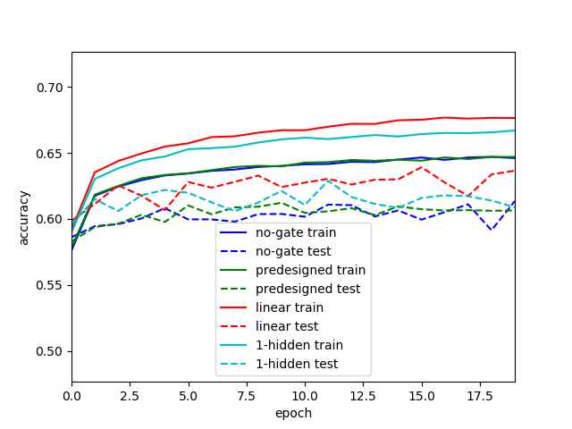

Figure . The accuracy curves of different models with linear experts on mixture dataset. Blue is the single expert, green is the pre-designed gate, red is the linear gate, cyan is 1-hidden-layer gate. Solid line is on train data, dashed line on test data.

The activation matrices of super-labels (Figure 4) shows that the frequency of using experts are unbalanced. In the case of 1-hidden-layer gate, expert 2 predicts on only part of mnist, whereas expert 1 predicts on whole cifar-10 and part of mnist.

|  |  |  |  |
| --- | --- | --- | --- |
| Model |  | Expert 1 | Expert 2 |
| Pre-designed gate | Mnist | 1.00 | 0.00 |
|  | Cifar | 0.00 | 1.00 |
| Linear gate | Mnist | 0.81 | 0.19 |
|  | Cifar | 0.39 | 0.61 |
| 1-hidden layer gate | Mnist | 0.34 | 0.66 |
|  | Cifar | 1.00 | 0.00 |

Figure The activation matrices of super-labels on the test set after training.

To see how 1-hidden-layer gate behave, we plot the activation per class in Figure 5 and confusions of 1-hidden-layer gate in Figure 6,**Error! Reference source not found.**. The expert 1 and expert 2 on mnist are specialized to predict classes {0,2,3,4,8,9} and {5,6,7}. Both experts could predict class 1. Expert 2 is confused on cifar-10 while expert 1 is not predicting cifar-10 images.

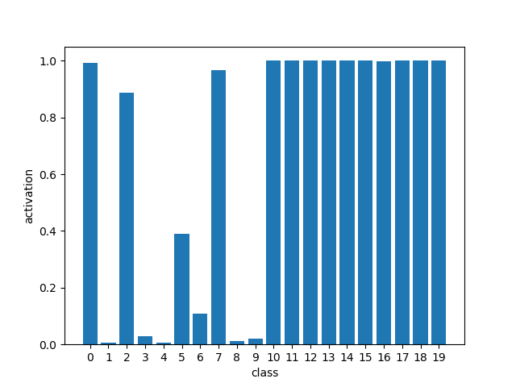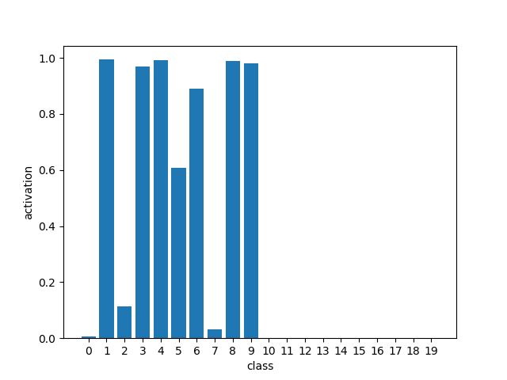

Figure . Activation of 1-hidden-layer gating per class. Left and right figures are of expert 1 and 2 correspondingly. Classes 0-9 are mnist labels and 10-19 are cifar-10 labels.

|  |  |  |  |  |  |  |  |  |  |  |  |  |  |  |  |  |  |  |  |  |  |  |
| --- | --- | --- | --- | --- | --- | --- | --- | --- | --- | --- | --- | --- | --- | --- | --- | --- | --- | --- | --- | --- | --- | --- |
| Overall confus. |  |  |  |  |  |  |  |  |  | Prediction | | | |  |  |  |  |  |  |  |  |  |
|  | **class** | 0 | 1 | 2 | 3 | 4 | 5 | 6 | 7 | 8 | 9 | 10 | 11 | 12 | 13 | 14 | 15 | 16 | 17 | 18 | 19 | **total** |
|  | 0 | 965 | 0 | 1 | 1 | 0 | 3 | 4 | 2 | 2 | 2 | 0 | 0 | 0 | 0 | 0 | 0 | 0 | 0 | 0 | 0 | **980** |
|  | 1 | 0 | 1117 | 1 | 3 | 0 | 0 | 4 | 1 | 9 | 0 | 0 | 0 | 0 | 0 | 0 | 0 | 0 | 0 | 0 | 0 | **1135** |
|  | 2 | 14 | 1 | 977 | 10 | 4 | 2 | 4 | 10 | 8 | 2 | 0 | 0 | 0 | 0 | 0 | 0 | 0 | 0 | 0 | 0 | **1032** |
|  | 3 | 0 | 1 | 6 | 949 | 2 | 11 | 1 | 5 | 26 | 9 | 0 | 0 | 0 | 0 | 0 | 0 | 0 | 0 | 0 | 0 | **1010** |
|  | 4 | 0 | 1 | 11 | 0 | 931 | 1 | 9 | 2 | 2 | 25 | 0 | 0 | 0 | 0 | 0 | 0 | 0 | 0 | 0 | 0 | **982** |
|  | 5 | 2 | 0 | 0 | 25 | 2 | 831 | 10 | 4 | 12 | 6 | 0 | 0 | 0 | 0 | 0 | 0 | 0 | 0 | 0 | 0 | **892** |
|  | 6 | 6 | 3 | 0 | 0 | 7 | 16 | 918 | 0 | 8 | 0 | 0 | 0 | 0 | 0 | 0 | 0 | 0 | 0 | 0 | 0 | **958** |
|  | 7 | 2 | 4 | 15 | 4 | 1 | 1 | 0 | 989 | 3 | 9 | 0 | 0 | 0 | 0 | 0 | 0 | 0 | 0 | 0 | 0 | **1028** |
| True | 8 | 1 | 3 | 4 | 19 | 11 | 4 | 6 | 6 | 902 | 18 | 0 | 0 | 0 | 0 | 0 | 0 | 0 | 0 | 0 | 0 | **974** |
|  | 9 | 4 | 6 | 0 | 12 | 21 | 4 | 0 | 12 | 5 | 945 | 0 | 0 | 0 | 0 | 0 | 0 | 0 | 0 | 0 | 0 | **1009** |
|  | 10 | 0 | 0 | 0 | 0 | 0 | 0 | 0 | 0 | 0 | 0 | 191 | 20 | 33 | 72 | 69 | 3 | 13 | 77 | 480 | 42 | **1000** |
|  | 11 | 0 | 0 | 0 | 0 | 0 | 0 | 0 | 0 | 0 | 0 | 20 | 233 | 11 | 65 | 72 | 2 | 27 | 61 | 334 | 175 | **1000** |
|  | 12 | 0 | 0 | 0 | 0 | 0 | 0 | 0 | 0 | 0 | 0 | 61 | 28 | 90 | 147 | 168 | 11 | 59 | 91 | 324 | 21 | **1000** |
|  | 13 | 0 | 0 | 0 | 0 | 0 | 0 | 0 | 0 | 0 | 0 | 51 | 28 | 46 | 264 | 167 | 26 | 45 | 73 | 243 | 57 | **1000** |
|  | 14 | 0 | 0 | 0 | 0 | 0 | 0 | 0 | 0 | 0 | 0 | 42 | 17 | 52 | 163 | 303 | 4 | 46 | 111 | 233 | 29 | **1000** |
|  | 15 | 0 | 0 | 0 | 0 | 0 | 1 | 0 | 0 | 0 | 0 | 50 | 13 | 54 | 173 | 168 | 96 | 31 | 85 | 299 | 30 | **1000** |
|  | 16 | 0 | 0 | 0 | 0 | 1 | 0 | 0 | 0 | 0 | 0 | 30 | 44 | 34 | 229 | 163 | 11 | 133 | 76 | 228 | 51 | **1000** |
|  | 17 | 0 | 0 | 0 | 0 | 0 | 0 | 0 | 0 | 0 | 0 | 23 | 20 | 42 | 113 | 163 | 13 | 25 | 254 | 293 | 54 | **1000** |
|  | 18 | 0 | 0 | 1 | 0 | 0 | 0 | 0 | 0 | 0 | 0 | 25 | 31 | 6 | 60 | 25 | 10 | 9 | 40 | 717 | 76 | **1000** |
|  | 19 | 1 | 0 | 0 | 0 | 0 | 0 | 0 | 0 | 0 | 0 | 32 | 80 | 15 | 44 | 41 | 2 | 14 | 52 | 346 | 373 | **1000** |
|  | **total** | **995** | **1136** | **1016** | **1023** | **980** | **874** | **956** | **1031** | **977** | **1016** | **525** | **514** | **383** | **1330** | **1339** | **178** | **402** | **920** | **3497** | **908** | **20000** |

Figure . Overall confusion matrix of 1-hidden-layer gate. Row and column indices represent the true and predicted labels. Classes 0-9 and 10-19 are mnist and cifar-10 labels correspondingly. This is computed on the test set of 20000 elements.

|  |  |  |  |  |  |  |  |  |  |  |  |  |  |  |  |  |  |  |  |  |  |  |
| --- | --- | --- | --- | --- | --- | --- | --- | --- | --- | --- | --- | --- | --- | --- | --- | --- | --- | --- | --- | --- | --- | --- |
| Expert 1 confusion |  |  |  |  |  |  |  |  |  | Prediction | | | |  |  |  |  |  |  |  |  |  |
|  | **class** | 0 | 1 | 2 | 3 | 4 | 5 | 6 | 7 | 8 | 9 | 10 | 11 | 12 | 13 | 14 | 15 | 16 | 17 | 18 | 19 | **total** |
|  | 0 | 965 | 0 | 1 | 0 | 0 | 3 | 2 | 2 | 0 | 1 | 0 | 0 | 0 | 0 | 0 | 0 | 0 | 0 | 0 | 0 | **974** |
|  | 1 | 0 | 4 | 1 | 0 | 0 | 0 | 0 | 1 | 0 | 0 | 0 | 0 | 0 | 0 | 0 | 0 | 0 | 0 | 0 | 0 | **6** |
|  | 2 | 14 | 1 | 890 | 3 | 1 | 2 | 1 | 10 | 1 | 0 | 0 | 0 | 0 | 0 | 0 | 0 | 0 | 0 | 0 | 0 | **923** |
|  | 3 | 0 | 0 | 4 | 20 | 0 | 3 | 0 | 5 | 0 | 0 | 0 | 0 | 0 | 0 | 0 | 0 | 0 | 0 | 0 | 0 | **32** |
|  | 4 | 0 | 0 | 4 | 0 | 0 | 1 | 0 | 1 | 0 | 0 | 0 | 0 | 0 | 0 | 0 | 0 | 0 | 0 | 0 | 0 | **6** |
|  | 5 | 2 | 0 | 0 | 2 | 0 | 344 | 0 | 4 | 0 | 0 | 0 | 0 | 0 | 0 | 0 | 0 | 0 | 0 | 0 | 0 | **352** |
|  | 6 | 6 | 0 | 0 | 0 | 0 | 2 | 95 | 0 | 0 | 0 | 0 | 0 | 0 | 0 | 0 | 0 | 0 | 0 | 0 | 0 | **103** |
|  | 7 | 2 | 0 | 14 | 0 | 1 | 1 | 0 | 978 | 0 | 0 | 0 | 0 | 0 | 0 | 0 | 0 | 0 | 0 | 0 | 0 | **996** |
| True | 8 | 1 | 0 | 3 | 1 | 0 | 1 | 0 | 6 | 0 | 0 | 0 | 0 | 0 | 0 | 0 | 0 | 0 | 0 | 0 | 0 | **12** |
|  | 9 | 4 | 0 | 0 | 0 | 0 | 1 | 0 | 12 | 0 | 4 | 0 | 0 | 0 | 0 | 0 | 0 | 0 | 0 | 0 | 0 | **21** |
|  | 10 | 0 | 0 | 0 | 0 | 0 | 0 | 0 | 0 | 0 | 0 | 191 | 20 | 33 | 72 | 69 | 3 | 13 | 77 | 480 | 42 | **1000** |
|  | 11 | 0 | 0 | 0 | 0 | 0 | 0 | 0 | 0 | 0 | 0 | 20 | 233 | 11 | 65 | 72 | 2 | 27 | 61 | 334 | 175 | **1000** |
|  | 12 | 0 | 0 | 0 | 0 | 0 | 0 | 0 | 0 | 0 | 0 | 61 | 28 | 90 | 147 | 168 | 11 | 59 | 91 | 324 | 21 | **1000** |
|  | 13 | 0 | 0 | 0 | 0 | 0 | 0 | 0 | 0 | 0 | 0 | 51 | 28 | 46 | 264 | 167 | 26 | 45 | 73 | 243 | 57 | **1000** |
|  | 14 | 0 | 0 | 0 | 0 | 0 | 0 | 0 | 0 | 0 | 0 | 42 | 17 | 52 | 163 | 303 | 4 | 46 | 111 | 233 | 29 | **1000** |
|  | 15 | 0 | 0 | 0 | 0 | 0 | 1 | 0 | 0 | 0 | 0 | 50 | 13 | 54 | 173 | 168 | 96 | 31 | 85 | 299 | 30 | **1000** |
|  | 16 | 0 | 0 | 0 | 0 | 0 | 0 | 0 | 0 | 0 | 0 | 30 | 44 | 34 | 229 | 163 | 11 | 133 | 76 | 228 | 51 | **999** |
|  | 17 | 0 | 0 | 0 | 0 | 0 | 0 | 0 | 0 | 0 | 0 | 23 | 20 | 42 | 113 | 163 | 13 | 25 | 254 | 293 | 54 | **1000** |
|  | 18 | 0 | 0 | 1 | 0 | 0 | 0 | 0 | 0 | 0 | 0 | 25 | 31 | 6 | 60 | 25 | 10 | 9 | 40 | 717 | 76 | **1000** |
|  | 19 | 1 | 0 | 0 | 0 | 0 | 0 | 0 | 0 | 0 | 0 | 32 | 80 | 15 | 44 | 41 | 2 | 14 | 52 | 346 | 373 | **1000** |
|  | **total** | **995** | **5** | **918** | **26** | **2** | **359** | **98** | **1019** | **1** | **5** | **525** | **514** | **383** | **1330** | **1339** | **178** | **402** | **920** | **3497** | **908** | **13424** |

Figure . Confusion matrix of expert 1 of 1-hidden-layer gate. Row and column indices represent the true and predicted labels. Classes 0-9 and 10-19 are mnist and cifar-10 labels correspondingly. This expert’s responsible set has 13424 elements.

* 1. Result 2 – Mixture datasets, convolutional experts, different gating functions

Comparing to the accuracy of linear experts, the accuracy of convolutional experts (Figure 7) is higher. The mixture of convolutional experts is not performing better than using a single expert in this task.

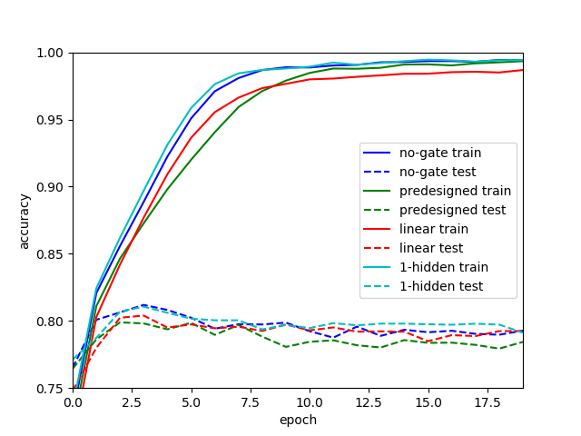

Figure Epoch-Accuracy plot with convolutional experts on mixture dataset.

Figure 6 shows the activation on super-labels. The 1-hidden layer gate is specialized to separate most of mnist and cifar-10 images, whereas the linear gate is relying on expert 1 and ignoring expert 2.

|  |  |  |  |
| --- | --- | --- | --- |
| Model |  | Expert 1 | Expert 2 |
| Linear gate | Mnist | 1.00 | 0.00 |
|  | Cifar | 1.00 | 0.00 |
| 1-hidden layer gate | Mnist | 0.88 | 0.12 |
|  | Cifar | 0.00 | 1.00 |

Figure Activation matrix with convolutional experts on mixture dataset

* 1. Result 3 – Mixture dataset, linear experts, different number of experts

The number of experts is in the list [1,2,3,4,6,8,10,12,16,20]. Not every number in the range [1,20] is evaluated. Figure 9 shows that the accuracy increases when number of experts increases. The accuracy begins to converge when number of experts is greater than 4.

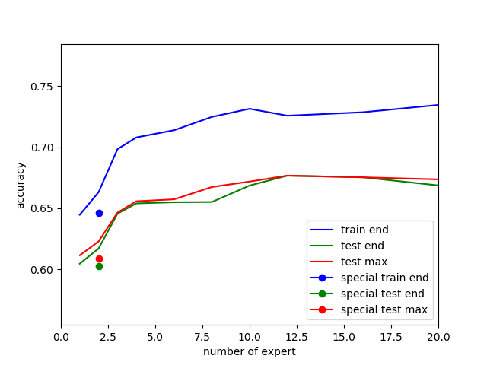

Figure number of experts - accuracy plot on mixture dataset, with 1-hidden-layer gate and linear experts. The special dots represent the result of pre-designed gate. Blue is the accuracy on the train set after training, green is the accuracy on the test set after training, and red is the maximum accuracy after each training epoch on the test set.

From activation matrices (Figure 10), we could see, there are few experts being pinched off when number of experts is high. We could see also that some experts specialize on mnist, some on cifar-10, while some predicts both.

|  |  |  |  |  |  |  |  |  |  |  |  |  |  |  |  |  |  |  |  |  |
| --- | --- | --- | --- | --- | --- | --- | --- | --- | --- | --- | --- | --- | --- | --- | --- | --- | --- | --- | --- | --- |
| Activation |  |  |  |  |  |  |  |  | Expert | | | |  |  |  |  |  |  |  |  |
| N=1 |  |  |  |  |  |  |  |  |  |  |  |  |  |  |  |  |  |  |  |  |
| Mnist | 1 |  |  |  |  |  |  |  |  |  |  |  |  |  |  |  |  |  |  |  |
| CIFAR-10 | 1 |  |  |  |  |  |  |  |  |  |  |  |  |  |  |  |  |  |  |  |
| N=2 |  |  |  |  |  |  |  |  |  |  |  |  |  |  |  |  |  |  |  |  |
| Mnist | 0.67 | 0.33 |  |  |  |  |  |  |  |  |  |  |  |  |  |  |  |  |  |  |
| CIFAR-10 | 0 | 1 |  |  |  |  |  |  |  |  |  |  |  |  |  |  |  |  |  |  |
| N=3 |  |  |  |  |  |  |  |  |  |  |  |  |  |  |  |  |  |  |  |  |
| Mnist | 0.32 | 0 | 0.68 |  |  |  |  |  |  |  |  |  |  |  |  |  |  |  |  |  |
| CIFAR-10 | 0.38 | 0.54 | 0.08 |  |  |  |  |  |  |  |  |  |  |  |  |  |  |  |  |  |
| N=4 |  |  |  |  |  |  |  |  |  |  |  |  |  |  |  |  |  |  |  |  |
| Mnist | 0.05 | 0.05 | 0.52 | 0.39 |  |  |  |  |  |  |  |  |  |  |  |  |  |  |  |  |
| CIFAR-10 | 0.41 | 0.34 | 0.02 | 0.23 |  |  |  |  |  |  |  |  |  |  |  |  |  |  |  |  |
| N=6 |  |  |  |  |  |  |  |  |  |  |  |  |  |  |  |  |  |  |  |  |
| Mnist | 0.34 | 0.23 | 0 | 0.43 | 0 | 0 |  |  |  |  |  |  |  |  |  |  |  |  |  |  |
| CIFAR-10 | 0.24 | 0.15 | 0.14 | 0.09 | 0.09 | 0.29 |  |  |  |  |  |  |  |  |  |  |  |  |  |  |
| N=8 |  |  |  |  |  |  |  |  |  |  |  |  |  |  |  |  |  |  |  |  |
| Mnist | 0.27 | 0.08 | 0.06 | 0 | 0 | 0.28 | 0.32 | 0 |  |  |  |  |  |  |  |  |  |  |  |  |
| CIFAR-10 | 0 | 0.22 | 0.19 | 0.16 | 0.02 | 0.08 | 0.15 | 0.18 |  |  |  |  |  |  |  |  |  |  |  |  |
| N=10 |  |  |  |  |  |  |  |  |  |  |  |  |  |  |  |  |  |  |  |  |
| Mnist | 0.18 | 0 | 0.28 | 0.22 | 0 | 0.32 | 0 | 0 | 0 | 0 |  |  |  |  |  |  |  |  |  |  |
| CIFAR-10 | 0.22 | 0.07 | 0.08 | 0.11 | 0.1 | 0.14 | 0.06 | 0.03 | 0.08 | 0.14 |  |  |  |  |  |  |  |  |  |  |
| N=12 |  |  |  |  |  |  |  |  |  |  |  |  |  |  |  |  |  |  |  |  |
| Mnist | 0.24 | 0.23 | 0.11 | 0 | 0 | 0 | 0 | 0 | 0 | 0 | 0.38 | 0.03 |  |  |  |  |  |  |  |  |
| CIFAR-10 | 0.04 | 0.17 | 0 | 0.08 | 0.24 | 0.06 | 0.06 | 0.08 | 0.1 | 0.06 | 0.01 | 0.09 |  |  |  |  |  |  |  |  |
| N=16 |  |  |  |  |  |  |  |  |  |  |  |  |  |  |  |  |  |  |  |  |
| Mnist | 0 | 0.46 | 0 | 0 | 0 | 0 | 0 | 0 | 0 | 0.02 | 0 | 0 | 0.32 | 0 | 0.2 | 0 |  |  |  |  |
| CIFAR-10 | 0.11 | 0.15 | 0.15 | 0.05 | 0.02 | 0.04 | 0.07 | 0.02 | 0.1 | 0.06 | 0.05 | 0.03 | 0.01 | 0.04 | 0.05 | 0.06 |  |  |  |  |
| N=20 |  |  |  |  |  |  |  |  |  |  |  |  |  |  |  |  |  |  |  |  |
| Mnist | 0 | 0 | 0 | 0 | 0.25 | 0 | 0 | 0 | 0 | 0 | 0.2 | 0 | 0 | 0 | 0 | 0.22 | 0 | 0.21 | 0.13 | 0 |
| CIFAR-10 | 0.03 | 0 | 0.04 | 0.09 | 0.01 | 0.04 | 0.06 | 0 | 0.03 | 0.13 | 0.02 | 0.05 | 0.03 | 0.03 | 0 | 0.17 | 0.11 | 0.06 | 0.07 | 0.05 |

Figure . Activation matrices with different number of experts with linear experts on mixture dataset.

Here, we plot the activation (Figure 11) and confusion (Figure 12Figure 13Figure 14,Figure 15Figure 16) of 4 experts to see some details.

Figure . Activation per class of 4 experts. Top left is 1. expert, top right is 2., bot left is 3. And bot right is 4. Notice that each y axes have different scales.

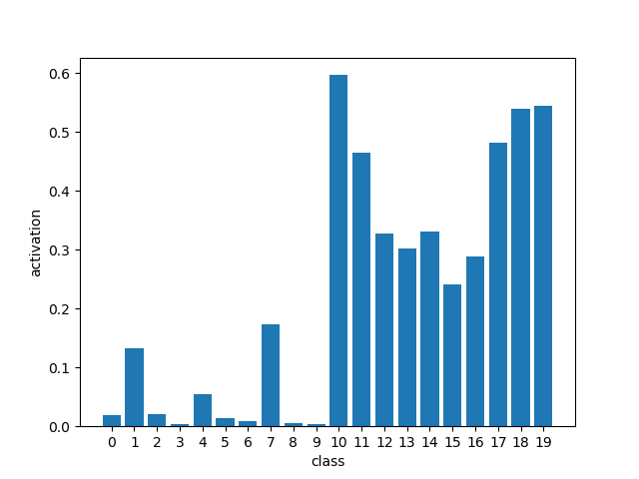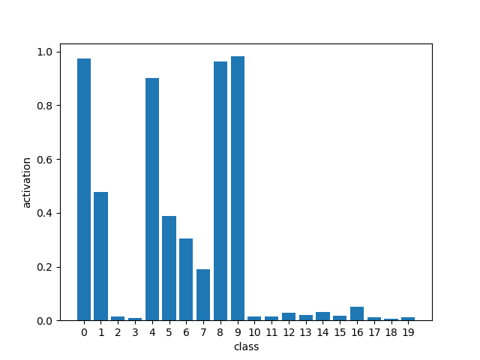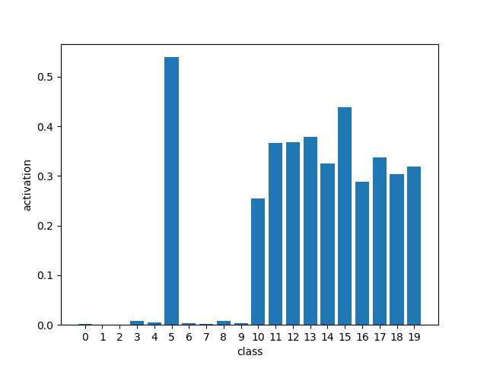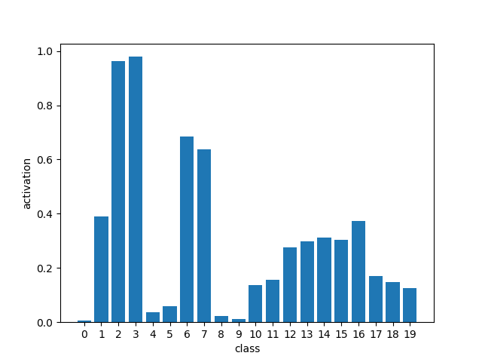

|  |  |  |  |  |  |  |  |  |  |  |  |  |  |  |  |  |  |  |  |  |  |  |
| --- | --- | --- | --- | --- | --- | --- | --- | --- | --- | --- | --- | --- | --- | --- | --- | --- | --- | --- | --- | --- | --- | --- |
| Overall confus. |  |  |  |  |  |  |  |  |  | Prediction | | | |  |  |  |  |  |  |  |  |  |
|  | **class** | 0 | 1 | 2 | 3 | 4 | 5 | 6 | 7 | 8 | 9 | 10 | 11 | 12 | 13 | 14 | 15 | 16 | 17 | 18 | 19 | **total** |
|  | 0 | 964 | 0 | 0 | 1 | 1 | 2 | 7 | 1 | 3 | 1 | 0 | 0 | 0 | 0 | 0 | 0 | 0 | 0 | 0 | 0 | **980** |
|  | 1 | 0 | 1122 | 2 | 3 | 1 | 0 | 2 | 2 | 3 | 0 | 0 | 0 | 0 | 0 | 0 | 0 | 0 | 0 | 0 | 0 | **1135** |
|  | 2 | 6 | 5 | 975 | 22 | 5 | 1 | 6 | 8 | 3 | 0 | 1 | 0 | 0 | 0 | 0 | 0 | 0 | 0 | 0 | 0 | **1032** |
|  | 3 | 0 | 0 | 12 | 977 | 1 | 5 | 0 | 9 | 5 | 1 | 0 | 0 | 0 | 0 | 0 | 0 | 0 | 0 | 0 | 0 | **1010** |
|  | 4 | 0 | 1 | 3 | 1 | 935 | 1 | 3 | 2 | 3 | 33 | 0 | 0 | 0 | 0 | 0 | 0 | 0 | 0 | 0 | 0 | **982** |
|  | 5 | 4 | 0 | 3 | 17 | 2 | 843 | 7 | 1 | 10 | 5 | 0 | 0 | 0 | 0 | 0 | 0 | 0 | 0 | 0 | 0 | **892** |
|  | 6 | 7 | 3 | 10 | 0 | 6 | 8 | 917 | 2 | 5 | 0 | 0 | 0 | 0 | 0 | 0 | 0 | 0 | 0 | 0 | 0 | **958** |
|  | 7 | 0 | 5 | 18 | 12 | 5 | 1 | 0 | 976 | 3 | 8 | 0 | 0 | 0 | 0 | 0 | 0 | 0 | 0 | 0 | 0 | **1028** |
| True | 8 | 4 | 0 | 4 | 15 | 9 | 16 | 2 | 5 | 909 | 10 | 0 | 0 | 0 | 0 | 0 | 0 | 0 | 0 | 0 | 0 | **974** |
|  | 9 | 7 | 5 | 1 | 3 | 13 | 8 | 0 | 6 | 12 | 954 | 0 | 0 | 0 | 0 | 0 | 0 | 0 | 0 | 0 | 0 | **1009** |
|  | 10 | 0 | 0 | 0 | 0 | 0 | 0 | 0 | 0 | 0 | 0 | 508 | 27 | 48 | 61 | 50 | 4 | 55 | 95 | 126 | 26 | **1000** |
|  | 11 | 0 | 0 | 0 | 0 | 0 | 0 | 0 | 0 | 0 | 0 | 111 | 395 | 12 | 63 | 27 | 6 | 68 | 54 | 140 | 124 | **1000** |
|  | 12 | 0 | 0 | 0 | 0 | 0 | 0 | 0 | 0 | 0 | 0 | 151 | 20 | 164 | 171 | 156 | 37 | 146 | 89 | 50 | 16 | **1000** |
|  | 13 | 0 | 0 | 0 | 0 | 0 | 0 | 0 | 0 | 0 | 0 | 89 | 29 | 70 | 302 | 81 | 77 | 150 | 88 | 64 | 50 | **1000** |
|  | 14 | 0 | 0 | 0 | 0 | 0 | 0 | 0 | 0 | 0 | 0 | 128 | 16 | 75 | 161 | 262 | 16 | 165 | 122 | 41 | 14 | **1000** |
|  | 15 | 0 | 0 | 0 | 0 | 0 | 1 | 0 | 0 | 0 | 0 | 83 | 12 | 81 | 254 | 63 | 192 | 90 | 107 | 94 | 23 | **1000** |
|  | 16 | 0 | 0 | 0 | 0 | 0 | 0 | 0 | 0 | 0 | 0 | 91 | 45 | 44 | 142 | 119 | 21 | 418 | 64 | 32 | 24 | **1000** |
|  | 17 | 0 | 0 | 0 | 0 | 0 | 0 | 0 | 0 | 0 | 0 | 108 | 19 | 62 | 124 | 61 | 29 | 55 | 435 | 66 | 41 | **1000** |
|  | 18 | 0 | 0 | 0 | 0 | 0 | 0 | 0 | 0 | 0 | 0 | 216 | 73 | 23 | 56 | 21 | 12 | 28 | 49 | 460 | 62 | **1000** |
|  | 19 | 0 | 0 | 0 | 0 | 1 | 0 | 0 | 0 | 0 | 0 | 99 | 148 | 19 | 66 | 16 | 10 | 50 | 74 | 145 | 372 | **1000** |
|  | **total** | **992** | **1141** | **1028** | **1051** | **979** | **886** | **944** | **1012** | **956** | **1012** | **1585** | **784** | **598** | **1400** | **856** | **404** | **1225** | **1177** | **1218** | **752** | **20000** |

Figure . Overall confusion of 4 experts.

|  |  |  |  |  |  |  |  |  |  |  |  |  |  |  |  |  |  |  |  |  |  |  |  |
| --- | --- | --- | --- | --- | --- | --- | --- | --- | --- | --- | --- | --- | --- | --- | --- | --- | --- | --- | --- | --- | --- | --- | --- |
| Expert 1 confusion |  |  |  |  |  |  |  |  |  | | Prediction | | | |  |  |  |  |  |  |  |  |  |
|  | **class** | 0 | 1 | 2 | 3 | 4 | 5 | 6 | 7 | 8 | | 9 | 10 | 11 | 12 | 13 | 14 | 15 | 16 | 17 | 18 | 19 | **total** |
|  | 0 | 17 | 0 | 0 | 0 | 0 | 0 | 0 | 0 | | 0 | 0 | 0 | 0 | 0 | 0 | 0 | 0 | 0 | 0 | 0 | 0 | **17** |
|  | 1 | 0 | 135 | 0 | 0 | 0 | 0 | 0 | 0 | | 0 | 0 | 0 | 0 | 0 | 0 | 0 | 0 | 0 | 0 | 0 | 0 | **135** |
|  | 2 | 1 | 1 | 18 | 0 | 1 | 0 | 0 | 2 | | 0 | 0 | 0 | 0 | 0 | 0 | 0 | 0 | 0 | 0 | 0 | 0 | **23** |
|  | 3 | 0 | 0 | 0 | 0 | 0 | 0 | 0 | 4 | | 0 | 0 | 0 | 0 | 0 | 0 | 0 | 0 | 0 | 0 | 0 | 0 | **4** |
|  | 4 | 0 | 0 | 0 | 0 | 46 | 0 | 0 | 0 | | 0 | 0 | 0 | 0 | 0 | 0 | 0 | 0 | 0 | 0 | 0 | 0 | **46** |
|  | 5 | 0 | 0 | 0 | 0 | 0 | 10 | 0 | 1 | | 0 | 0 | 0 | 0 | 0 | 0 | 0 | 0 | 0 | 0 | 0 | 0 | **11** |
|  | 6 | 1 | 0 | 2 | 0 | 4 | 0 | 2 | 1 | | 0 | 0 | 0 | 0 | 0 | 0 | 0 | 0 | 0 | 0 | 0 | 0 | **10** |
|  | 7 | 0 | 0 | 1 | 0 | 1 | 0 | 0 | 172 | | 0 | 0 | 0 | 0 | 0 | 0 | 0 | 0 | 0 | 0 | 0 | 0 | **174** |
| True | 8 | 0 | 0 | 0 | 0 | 2 | 1 | 0 | 1 | | 0 | 0 | 0 | 0 | 0 | 0 | 0 | 0 | 0 | 0 | 0 | 0 | **4** |
|  | 9 | 0 | 0 | 0 | 0 | 0 | 0 | 0 | 0 | | 0 | 0 | 0 | 0 | 0 | 0 | 0 | 0 | 0 | 0 | 0 | 0 | **0** |
|  | 10 | 0 | 0 | 0 | 0 | 0 | 0 | 0 | 0 | | 0 | 0 | 465 | 17 | 24 | 7 | 11 | 0 | 17 | 82 | 79 | 16 | **718** |
|  | 11 | 0 | 0 | 0 | 0 | 0 | 0 | 0 | 0 | | 0 | 0 | 94 | 174 | 5 | 12 | 2 | 0 | 20 | 29 | 91 | 80 | **507** |
|  | 12 | 0 | 0 | 0 | 0 | 0 | 0 | 0 | 0 | | 0 | 0 | 132 | 12 | 70 | 20 | 21 | 1 | 18 | 57 | 19 | 7 | **357** |
|  | 13 | 0 | 0 | 0 | 0 | 0 | 0 | 0 | 0 | | 0 | 0 | 81 | 13 | 31 | 35 | 10 | 4 | 52 | 63 | 16 | 24 | **329** |
|  | 14 | 0 | 0 | 0 | 0 | 0 | 0 | 0 | 0 | | 0 | 0 | 111 | 9 | 36 | 25 | 36 | 0 | 22 | 86 | 22 | 6 | **353** |
|  | 15 | 0 | 0 | 0 | 0 | 0 | 0 | 0 | 0 | | 0 | 0 | 71 | 6 | 27 | 24 | 4 | 4 | 27 | 65 | 11 | 14 | **253** |
|  | 16 | 0 | 0 | 0 | 0 | 0 | 0 | 0 | 0 | | 0 | 0 | 85 | 29 | 16 | 37 | 20 | 0 | 96 | 32 | 14 | 12 | **341** |
|  | 17 | 0 | 0 | 0 | 0 | 0 | 0 | 0 | 0 | | 0 | 0 | 101 | 5 | 30 | 11 | 10 | 1 | 11 | 325 | 36 | 28 | **558** |
|  | 18 | 0 | 0 | 0 | 0 | 0 | 0 | 0 | 0 | | 0 | 0 | 200 | 41 | 9 | 7 | 3 | 0 | 7 | 37 | 281 | 38 | **623** |
|  | 19 | 0 | 0 | 0 | 0 | 0 | 0 | 0 | 0 | | 0 | 0 | 98 | 77 | 3 | 19 | 2 | 2 | 28 | 54 | 86 | 264 | **633** |
|  | **total** | **19** | **136** | **21** | **0** | **54** | **11** | **2** | **181** | | **0** | **0** | **1438** | **383** | **251** | **197** | **119** | **12** | **298** | **830** | **655** | **489** | **5096** |

Figure . Confusion of Expert 1 from 4 experts.

|  |  |  |  |  |  |  |  |  |  |  |  |  |  |  |  |  |  |  |  |  |  |  |  |
| --- | --- | --- | --- | --- | --- | --- | --- | --- | --- | --- | --- | --- | --- | --- | --- | --- | --- | --- | --- | --- | --- | --- | --- |
| Expert 2 confusion |  |  |  |  |  |  |  |  |  | | Prediction | | | |  |  |  |  |  |  |  |  |  |
|  | **class** | 0 | 1 | 2 | 3 | 4 | 5 | 6 | 7 | 8 | | 9 | 10 | 11 | 12 | 13 | 14 | 15 | 16 | 17 | 18 | 19 | **total** |
|  | 0 | 0 | 0 | 0 | 0 | 0 | 1 | 0 | 0 | | 0 | 0 | 0 | 0 | 0 | 0 | 0 | 0 | 0 | 0 | 0 | 0 | **1** |
|  | 1 | 0 | 0 | 0 | 0 | 0 | 0 | 0 | 0 | | 0 | 0 | 0 | 0 | 0 | 0 | 0 | 0 | 0 | 0 | 0 | 0 | **0** |
|  | 2 | 0 | 0 | 0 | 0 | 0 | 0 | 0 | 0 | | 0 | 0 | 0 | 0 | 0 | 0 | 0 | 0 | 0 | 0 | 0 | 0 | **0** |
|  | 3 | 0 | 0 | 0 | 1 | 0 | 4 | 0 | 0 | | 0 | 0 | 0 | 0 | 0 | 0 | 0 | 0 | 0 | 0 | 0 | 0 | **5** |
|  | 4 | 0 | 0 | 0 | 0 | 3 | 1 | 0 | 0 | | 0 | 0 | 0 | 0 | 0 | 0 | 0 | 0 | 0 | 0 | 0 | 0 | **4** |
|  | 5 | 0 | 0 | 0 | 0 | 0 | 475 | 0 | 0 | | 0 | 0 | 0 | 0 | 0 | 0 | 0 | 0 | 0 | 0 | 0 | 0 | **475** |
|  | 6 | 0 | 0 | 0 | 0 | 0 | 2 | 0 | 0 | | 0 | 0 | 0 | 0 | 0 | 0 | 0 | 0 | 0 | 0 | 0 | 0 | **2** |
|  | 7 | 0 | 0 | 0 | 0 | 1 | 0 | 0 | 0 | | 0 | 0 | 0 | 0 | 0 | 0 | 0 | 0 | 0 | 0 | 0 | 0 | **1** |
| True | 8 | 0 | 0 | 0 | 0 | 0 | 6 | 0 | 0 | | 0 | 0 | 0 | 0 | 0 | 0 | 0 | 0 | 0 | 0 | 0 | 0 | **6** |
|  | 9 | 0 | 0 | 0 | 0 | 0 | 2 | 0 | 0 | | 0 | 0 | 0 | 0 | 0 | 0 | 0 | 0 | 0 | 0 | 0 | 0 | **2** |
|  | 10 | 0 | 0 | 0 | 0 | 0 | 0 | 0 | 0 | | 0 | 0 | 34 | 6 | 17 | 45 | 5 | 2 | 6 | 11 | 34 | 5 | **165** |
|  | 11 | 0 | 0 | 0 | 0 | 0 | 0 | 0 | 0 | | 0 | 0 | 15 | 194 | 3 | 43 | 4 | 2 | 6 | 23 | 39 | 28 | **357** |
|  | 12 | 0 | 0 | 0 | 0 | 0 | 0 | 0 | 0 | | 0 | 0 | 16 | 7 | 71 | 118 | 34 | 14 | 9 | 24 | 30 | 6 | **329** |
|  | 13 | 0 | 0 | 0 | 0 | 0 | 0 | 0 | 0 | | 0 | 0 | 7 | 15 | 27 | 195 | 12 | 17 | 16 | 23 | 44 | 10 | **366** |
|  | 14 | 0 | 0 | 0 | 0 | 0 | 0 | 0 | 0 | | 0 | 0 | 14 | 6 | 27 | 107 | 49 | 3 | 3 | 29 | 15 | 5 | **258** |
|  | 15 | 0 | 0 | 0 | 0 | 0 | 0 | 0 | 0 | | 0 | 0 | 8 | 5 | 40 | 166 | 16 | 85 | 10 | 34 | 71 | 7 | **442** |
|  | 16 | 0 | 0 | 0 | 0 | 0 | 0 | 0 | 0 | | 0 | 0 | 3 | 13 | 9 | 69 | 9 | 5 | 27 | 25 | 11 | 2 | **173** |
|  | 17 | 0 | 0 | 0 | 0 | 0 | 0 | 0 | 0 | | 0 | 0 | 6 | 14 | 25 | 90 | 15 | 10 | 8 | 98 | 28 | 9 | **303** |
|  | 18 | 0 | 0 | 0 | 0 | 0 | 0 | 0 | 0 | | 0 | 0 | 14 | 27 | 12 | 37 | 5 | 4 | 4 | 11 | 159 | 11 | **284** |
|  | 19 | 0 | 0 | 0 | 0 | 0 | 0 | 0 | 0 | | 0 | 0 | 0 | 58 | 12 | 39 | 5 | 4 | 7 | 19 | 54 | 74 | **272** |
|  | **total** | **0** | **0** | **0** | **1** | **4** | **491** | **0** | **0** | | **0** | **0** | **117** | **345** | **243** | **909** | **154** | **146** | **96** | **297** | **485** | **157** | **3445** |

Figure . Confusion of Expert 2 from 4 experts.

|  |  |  |  |  |  |  |  |  |  |  |  |  |  |  |  |  |  |  |  |  |  |  |  |
| --- | --- | --- | --- | --- | --- | --- | --- | --- | --- | --- | --- | --- | --- | --- | --- | --- | --- | --- | --- | --- | --- | --- | --- |
| Expert 3 confusion |  |  |  |  |  |  |  |  |  | | Prediction | | | |  |  |  |  |  |  |  |  |  |
|  | **class** | 0 | 1 | 2 | 3 | 4 | 5 | 6 | 7 | 8 | | 9 | 10 | 11 | 12 | 13 | 14 | 15 | 16 | 17 | 18 | 19 | **total** |
|  | 0 | 946 | 0 | 0 | 0 | 1 | 1 | 4 | 1 | | 3 | 1 | 0 | 0 | 0 | 0 | 0 | 0 | 0 | 0 | 0 | 0 | **957** |
|  | 1 | 0 | 550 | 0 | 0 | 0 | 0 | 1 | 0 | | 3 | 0 | 0 | 0 | 0 | 0 | 0 | 0 | 0 | 0 | 0 | 0 | **554** |
|  | 2 | 5 | 0 | 2 | 0 | 2 | 1 | 0 | 1 | | 3 | 0 | 0 | 0 | 0 | 0 | 0 | 0 | 0 | 0 | 0 | 0 | **14** |
|  | 3 | 0 | 0 | 0 | 1 | 0 | 0 | 0 | 0 | | 5 | 1 | 0 | 0 | 0 | 0 | 0 | 0 | 0 | 0 | 0 | 0 | **7** |
|  | 4 | 0 | 1 | 1 | 0 | 854 | 0 | 2 | 1 | | 3 | 33 | 0 | 0 | 0 | 0 | 0 | 0 | 0 | 0 | 0 | 0 | **895** |
|  | 5 | 4 | 0 | 0 | 0 | 2 | 327 | 7 | 0 | | 10 | 5 | 0 | 0 | 0 | 0 | 0 | 0 | 0 | 0 | 0 | 0 | **355** |
|  | 6 | 5 | 2 | 1 | 0 | 2 | 5 | 270 | 0 | | 5 | 0 | 0 | 0 | 0 | 0 | 0 | 0 | 0 | 0 | 0 | 0 | **290** |
|  | 7 | 0 | 1 | 0 | 0 | 1 | 1 | 0 | 179 | | 3 | 8 | 0 | 0 | 0 | 0 | 0 | 0 | 0 | 0 | 0 | 0 | **193** |
| True | 8 | 4 | 0 | 1 | 0 | 6 | 9 | 2 | 2 | | 908 | 10 | 0 | 0 | 0 | 0 | 0 | 0 | 0 | 0 | 0 | 0 | **942** |
|  | 9 | 7 | 2 | 0 | 1 | 12 | 6 | 0 | 3 | | 12 | 954 | 0 | 0 | 0 | 0 | 0 | 0 | 0 | 0 | 0 | 0 | **997** |
|  | 10 | 0 | 0 | 0 | 0 | 0 | 0 | 0 | 0 | | 0 | 0 | 0 | 0 | 0 | 0 | 0 | 0 | 0 | 0 | 0 | 0 | **0** |
|  | 11 | 0 | 0 | 0 | 0 | 0 | 0 | 0 | 0 | | 0 | 0 | 0 | 0 | 0 | 0 | 0 | 0 | 0 | 0 | 0 | 0 | **0** |
|  | 12 | 0 | 0 | 0 | 0 | 0 | 0 | 0 | 0 | | 0 | 0 | 0 | 0 | 0 | 0 | 1 | 0 | 1 | 0 | 0 | 0 | **2** |
|  | 13 | 0 | 0 | 0 | 0 | 0 | 0 | 0 | 0 | | 0 | 0 | 0 | 0 | 0 | 0 | 1 | 0 | 1 | 0 | 0 | 0 | **2** |
|  | 14 | 0 | 0 | 0 | 0 | 0 | 0 | 0 | 0 | | 0 | 0 | 0 | 0 | 0 | 0 | 0 | 0 | 0 | 0 | 0 | 0 | **0** |
|  | 15 | 0 | 0 | 0 | 0 | 0 | 1 | 0 | 0 | | 0 | 0 | 0 | 0 | 0 | 0 | 0 | 0 | 0 | 0 | 0 | 0 | **1** |
|  | 16 | 0 | 0 | 0 | 0 | 0 | 0 | 0 | 0 | | 0 | 0 | 0 | 1 | 0 | 0 | 1 | 0 | 1 | 0 | 0 | 0 | **3** |
|  | 17 | 0 | 0 | 0 | 0 | 0 | 0 | 0 | 0 | | 0 | 0 | 0 | 0 | 0 | 0 | 0 | 0 | 0 | 0 | 0 | 0 | **0** |
|  | 18 | 0 | 0 | 0 | 0 | 0 | 0 | 0 | 0 | | 0 | 0 | 0 | 0 | 0 | 0 | 0 | 0 | 0 | 0 | 0 | 0 | **0** |
|  | 19 | 0 | 0 | 0 | 0 | 1 | 0 | 0 | 0 | | 0 | 0 | 0 | 0 | 0 | 0 | 0 | 0 | 0 | 0 | 0 | 0 | **1** |
|  | **total** | **971** | **556** | **5** | **2** | **881** | **351** | **286** | **187** | | **955** | **1012** | **0** | **1** | **0** | **0** | **3** | **0** | **3** | **0** | **0** | **0** | **5213** |

Figure . Confusion of Expert 3 from 4 experts.

|  |  |  |  |  |  |  |  |  |  |  |  |  |  |  |  |  |  |  |  |  |  |  |  |
| --- | --- | --- | --- | --- | --- | --- | --- | --- | --- | --- | --- | --- | --- | --- | --- | --- | --- | --- | --- | --- | --- | --- | --- |
| Expert 4 confusion |  |  |  |  |  |  |  |  |  | | Prediction | | | |  |  |  |  |  |  |  |  |  |
|  | **class** | 0 | 1 | 2 | 3 | 4 | 5 | 6 | 7 | 8 | | 9 | 10 | 11 | 12 | 13 | 14 | 15 | 16 | 17 | 18 | 19 | **total** |
|  | 0 | 1 | 0 | 0 | 1 | 0 | 0 | 3 | 0 | | 0 | 0 | 0 | 0 | 0 | 0 | 0 | 0 | 0 | 0 | 0 | 0 | **5** |
|  | 1 | 0 | 437 | 2 | 3 | 1 | 0 | 1 | 2 | | 0 | 0 | 0 | 0 | 0 | 0 | 0 | 0 | 0 | 0 | 0 | 0 | **446** |
|  | 2 | 0 | 4 | 955 | 22 | 2 | 0 | 6 | 5 | | 0 | 0 | 1 | 0 | 0 | 0 | 0 | 0 | 0 | 0 | 0 | 0 | **995** |
|  | 3 | 0 | 0 | 12 | 975 | 1 | 1 | 0 | 5 | | 0 | 0 | 0 | 0 | 0 | 0 | 0 | 0 | 0 | 0 | 0 | 0 | **994** |
|  | 4 | 0 | 0 | 2 | 1 | 32 | 0 | 1 | 1 | | 0 | 0 | 0 | 0 | 0 | 0 | 0 | 0 | 0 | 0 | 0 | 0 | **37** |
|  | 5 | 0 | 0 | 3 | 17 | 0 | 31 | 0 | 0 | | 0 | 0 | 0 | 0 | 0 | 0 | 0 | 0 | 0 | 0 | 0 | 0 | **51** |
|  | 6 | 1 | 1 | 7 | 0 | 0 | 1 | 645 | 1 | | 0 | 0 | 0 | 0 | 0 | 0 | 0 | 0 | 0 | 0 | 0 | 0 | **656** |
|  | 7 | 0 | 4 | 17 | 12 | 2 | 0 | 0 | 625 | | 0 | 0 | 0 | 0 | 0 | 0 | 0 | 0 | 0 | 0 | 0 | 0 | **660** |
| True | 8 | 0 | 0 | 3 | 15 | 1 | 0 | 0 | 2 | | 1 | 0 | 0 | 0 | 0 | 0 | 0 | 0 | 0 | 0 | 0 | 0 | **22** |
|  | 9 | 0 | 3 | 1 | 2 | 1 | 0 | 0 | 3 | | 0 | 0 | 0 | 0 | 0 | 0 | 0 | 0 | 0 | 0 | 0 | 0 | **10** |
|  | 10 | 0 | 0 | 0 | 0 | 0 | 0 | 0 | 0 | | 0 | 0 | 9 | 4 | 7 | 9 | 34 | 2 | 32 | 2 | 13 | 5 | **117** |
|  | 11 | 0 | 0 | 0 | 0 | 0 | 0 | 0 | 0 | | 0 | 0 | 2 | 27 | 4 | 8 | 21 | 4 | 42 | 2 | 10 | 16 | **136** |
|  | 12 | 0 | 0 | 0 | 0 | 0 | 0 | 0 | 0 | | 0 | 0 | 3 | 1 | 23 | 33 | 100 | 22 | 118 | 8 | 1 | 3 | **312** |
|  | 13 | 0 | 0 | 0 | 0 | 0 | 0 | 0 | 0 | | 0 | 0 | 1 | 1 | 12 | 72 | 58 | 56 | 81 | 2 | 4 | 16 | **303** |
|  | 14 | 0 | 0 | 0 | 0 | 0 | 0 | 0 | 0 | | 0 | 0 | 3 | 1 | 12 | 29 | 177 | 13 | 140 | 7 | 4 | 3 | **389** |
|  | 15 | 0 | 0 | 0 | 0 | 0 | 0 | 0 | 0 | | 0 | 0 | 4 | 1 | 14 | 64 | 43 | 103 | 53 | 8 | 12 | 2 | **304** |
|  | 16 | 0 | 0 | 0 | 0 | 0 | 0 | 0 | 0 | | 0 | 0 | 3 | 2 | 19 | 36 | 89 | 16 | 294 | 7 | 7 | 10 | **483** |
|  | 17 | 0 | 0 | 0 | 0 | 0 | 0 | 0 | 0 | | 0 | 0 | 1 | 0 | 7 | 23 | 36 | 18 | 36 | 12 | 2 | 4 | **139** |
|  | 18 | 0 | 0 | 0 | 0 | 0 | 0 | 0 | 0 | | 0 | 0 | 2 | 5 | 2 | 12 | 13 | 8 | 17 | 1 | 20 | 13 | **93** |
|  | 19 | 0 | 0 | 0 | 0 | 0 | 0 | 0 | 0 | | 0 | 0 | 1 | 13 | 4 | 8 | 9 | 4 | 15 | 1 | 5 | 34 | **94** |
|  | **total** | **2** | **449** | **1002** | **1048** | **40** | **33** | **656** | **644** | | **1** | **0** | **30** | **55** | **104** | **294** | **580** | **246** | **828** | **50** | **78** | **106** | **6246** |

Figure . Confusion of Expert 4 from 4 experts

* 1. Result 4 – Cifar-100, Linear experts, different number of experts

This experiment has exactly same setting as previous one, except the dataset is changed to cifar-100. This causes input and output to be sized from (28,28,1) and 20 to (32,32,3) and 100.

However, the accuracy plot (Figure 9) is reversed case from previous one: Accuracy decreases when number of experts increases. With low number of experts, the mixture of experts performs better than a single expert, but with high number of experts, it performs worse. I could not find an intuitive explanation for this.

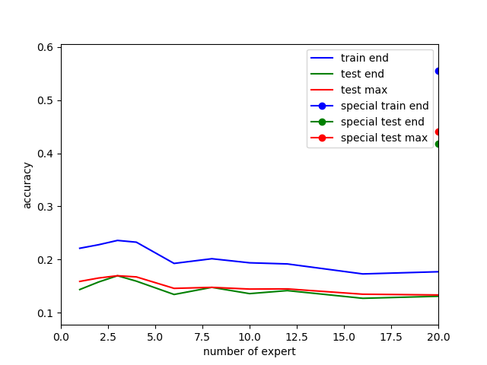

Figure . number of experts - accuracy plot on cifar-100 dataset. The special dots represent the result of pre-designed gate. Blue is the accuracy on the train set after training, green is the accuracy on the test set after training, and red is the maximum accuracy after each training epoch on the test set.

We plot the super-label activation table (Figure 18) and activation-per-class (Figure 19) of 4 experts. In this version of implementation, I forgot to group the classes into super-classes (i.e. the classes 0-4 are not super-class 0 and the classes 5-9 are not super-class 1 and so on), the activation-per-class figure is less informing. The expert 1 of 4 experts seems to be ignored and expert 2 has activation greater than 0.5 for most of classes.

|  |  |  |  |  |  |
| --- | --- | --- | --- | --- | --- |
| Model |  | Expert 1 | Expert 2 | Expert 3 | Expert 4 |
| 4 experts | aquatic_mammals | 0.01 | 0.57 | 0.23 | 0.19 |
|  | fish | 0.03 | 0.56 | 0.23 | 0.18 |
|  | flowers | 0.01 | 0.53 | 0.42 | 0.04 |
|  | food_containers | 0.01 | 0.58 | 0.31 | 0.09 |
|  | fruit_and_vegetables | 0.01 | 0.52 | 0.41 | 0.06 |
|  | household_electrical_devices | 0.01 | 0.58 | 0.29 | 0.12 |
|  | household_furniture | 0.01 | 0.60 | 0.33 | 0.06 |
|  | insects | 0.01 | 0.58 | 0.33 | 0.08 |
|  | large_carnivores | 0.02 | 0.55 | 0.35 | 0.08 |
|  | large_man-made_outdoor_things | 0.01 | 0.55 | 0.18 | 0.27 |
|  | large_natural_outdoor_scenes | 0.01 | 0.56 | 0.18 | 0.25 |
|  | large_omnivores_and_herbivores | 0.01 | 0.58 | 0.30 | 0.12 |
|  | medium_mammals | 0.02 | 0.58 | 0.31 | 0.09 |
|  | non-insect_invertebrates | 0.02 | 0.57 | 0.31 | 0.09 |
|  | people | 0.02 | 0.58 | 0.35 | 0.06 |
|  | reptiles | 0.02 | 0.58 | 0.29 | 0.11 |
|  | small_mammals | 0.02 | 0.57 | 0.33 | 0.08 |
|  | trees | 0.00 | 0.43 | 0.19 | 0.37 |
|  | vehicles_1 | 0.01 | 0.64 | 0.21 | 0.15 |
|  | vehicles_2 | 0.01 | 0.64 | 0.20 | 0.15 |

Figure . Super-label activation on 4 experts.

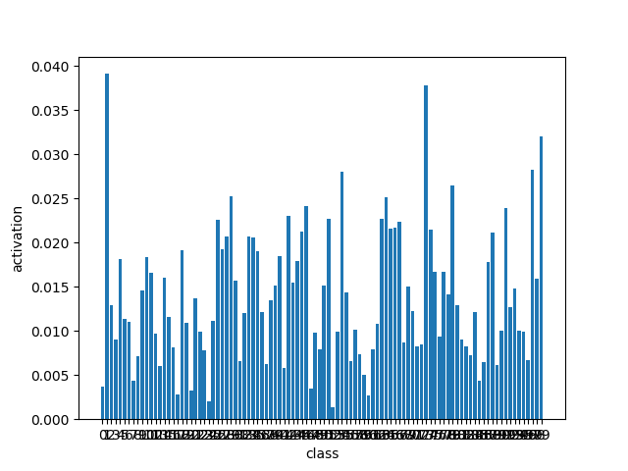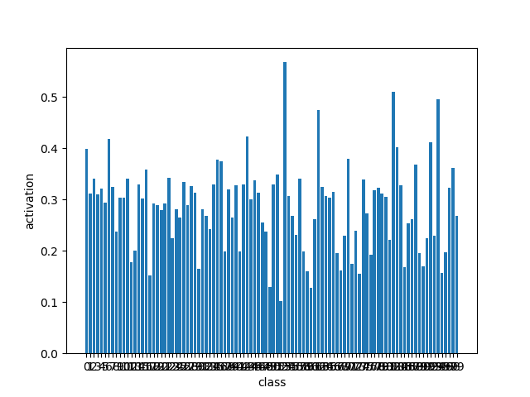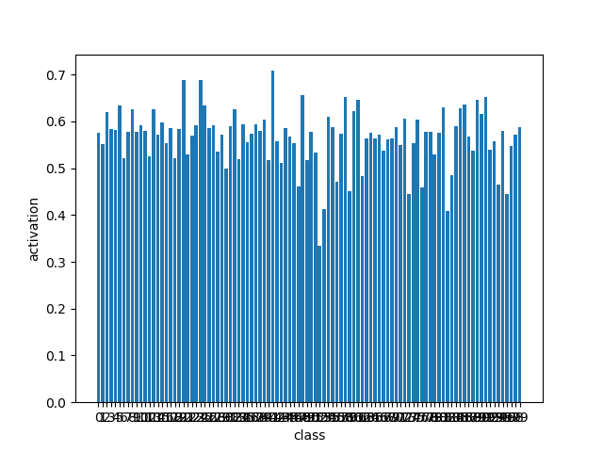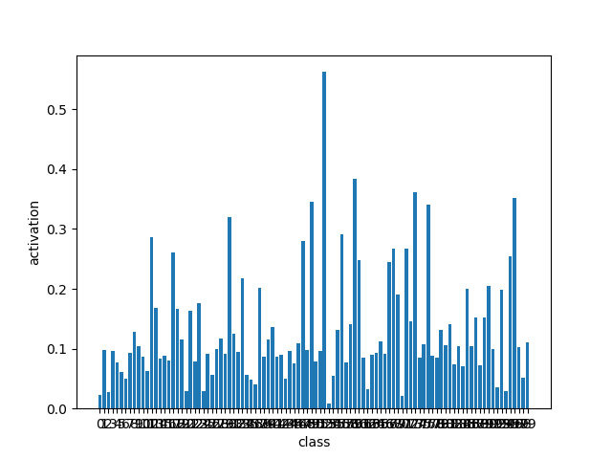

Figure . The per-class-activation on 4 experts. The x-axis is classes from 0 to 99. Classes are not grouped into super-classes by indices. Notice the y-axis has different scales.

* 1. Result 5 – Cifar-100, convolutional experts, different number of experts.

The number-of-experts-accuracy plot on this experiment (Figure 20) shows a different result from results 3 and 4. The different number of experts has little to no effect to the performance.

In both result 4 and 5, the pre-designed gate is performing significantly better than learning the gate. This result is different from models trained on mixture datasets, where the pre-designed gate is not performing better than a single expert.

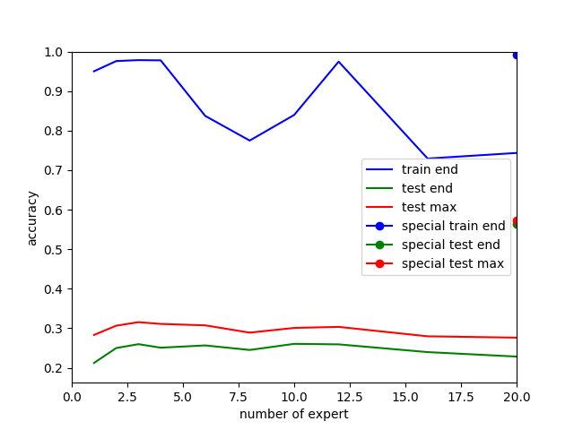

Figure . number of experts - accuracy plot on cifar-100 dataset with convolutional experts. The special dots represent the result of pre-designed gate. Blue is the accuracy on the train set after training, green is the accuracy on the test set after training, and red is the maximum accuracy after each training epoch on the test set.

For comparison, the per-class-activation of 4 experts is plotted. We could already see from it that every other expert is ignored except expert 1. The reason of stable accuracy of different number of experts might be this: there might be always only 1 expert that is activated.

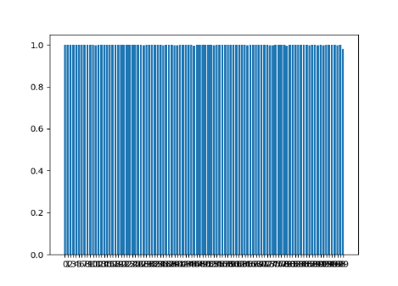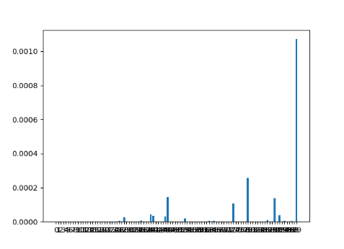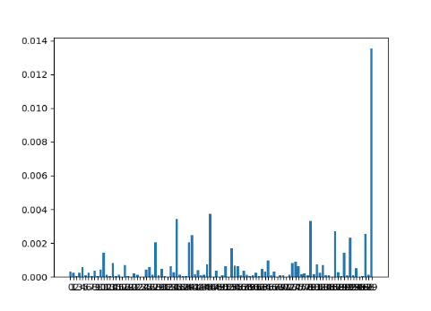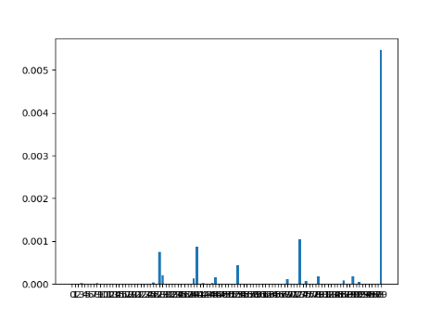

Figure . The per-class-activation on 4 convolutional experts. The x-axis is classes from 0 to 99. Classes are not grouped into super-classes by indices. Notice the y-axis has different scales.

* 1. Result 6 – Mixture dataset, convolutional experts, different number of experts

The accuracy (Figure 22) is also stable when number of experts increase. When we look at activations (Figure 23), we notice that there are many ignored experts. Some mixture has experts that are gated exactly as the pre-designed gate (with some 0-weighted experts). The per-class-activation and confusion of 4 experts are not plotted for comparison, because they behave similarly as single experts.

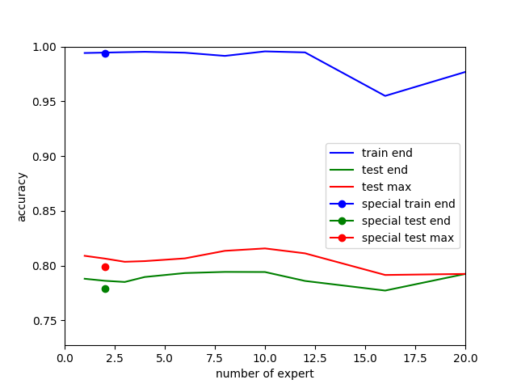

Figure . Number of experts - accuracy plot on mixture dataset with convolutional experts. Dots are results on pre-designed gate. Blue is accuracy on train set after training, green is accuracy on test set after training, red is the maximum accuracy on test set after each training epoch.

|  |  |  |  |  |  |  |  |  |  |  |  |  |  |  |  |  |  |  |  |  |
| --- | --- | --- | --- | --- | --- | --- | --- | --- | --- | --- | --- | --- | --- | --- | --- | --- | --- | --- | --- | --- |
| Activation |  |  |  |  |  |  |  |  | Expert | | | |  |  |  |  |  |  |  |  |
| N=1 |  |  |  |  |  |  |  |  |  |  |  |  |  |  |  |  |  |  |  |  |
| Mnist | 1 |  |  |  |  |  |  |  |  |  |  |  |  |  |  |  |  |  |  |  |
| CIFAR-10 | 1 |  |  |  |  |  |  |  |  |  |  |  |  |  |  |  |  |  |  |  |
| N=2 |  |  |  |  |  |  |  |  |  |  |  |  |  |  |  |  |  |  |  |  |
| Mnist | 0 | 1 |  |  |  |  |  |  |  |  |  |  |  |  |  |  |  |  |  |  |
| CIFAR-10 | 0 | 1 |  |  |  |  |  |  |  |  |  |  |  |  |  |  |  |  |  |  |
| N=3 |  |  |  |  |  |  |  |  |  |  |  |  |  |  |  |  |  |  |  |  |
| Mnist | 0.61 | 0.05 | 0.35 |  |  |  |  |  |  |  |  |  |  |  |  |  |  |  |  |  |
| CIFAR-10 | 0 | 1 | 0 |  |  |  |  |  |  |  |  |  |  |  |  |  |  |  |  |  |
| N=4 |  |  |  |  |  |  |  |  |  |  |  |  |  |  |  |  |  |  |  |  |
| Mnist | 1 | 0 | 0 | 0 |  |  |  |  |  |  |  |  |  |  |  |  |  |  |  |  |
| CIFAR-10 | 0 | 1 | 0 | 0 |  |  |  |  |  |  |  |  |  |  |  |  |  |  |  |  |
| N=6 |  |  |  |  |  |  |  |  |  |  |  |  |  |  |  |  |  |  |  |  |
| Mnist | 0.78 | 0 | 0 | 0 | 0 | 0.22 |  |  |  |  |  |  |  |  |  |  |  |  |  |  |
| CIFAR-10 | 0 | 0 | 0 | 1 | 0 | 0 |  |  |  |  |  |  |  |  |  |  |  |  |  |  |
| N=8 |  |  |  |  |  |  |  |  |  |  |  |  |  |  |  |  |  |  |  |  |
| Mnist | 0.89 | 0.11 | 0.01 | 0 | 0 | 0 | 0 | 0 |  |  |  |  |  |  |  |  |  |  |  |  |
| CIFAR-10 | 0 | 0 | 0.02 | 0 | 0 | 0 | 0.98 | 0 |  |  |  |  |  |  |  |  |  |  |  |  |
| N=10 |  |  |  |  |  |  |  |  |  |  |  |  |  |  |  |  |  |  |  |  |
| Mnist | 0 | 0 | 0 | 0 | 0 | 0 | 0 | 0 | 1 | 0 |  |  |  |  |  |  |  |  |  |  |
| CIFAR-10 | 1 | 0 | 0 | 0 | 0 | 0 | 0 | 0 | 0 | 0 |  |  |  |  |  |  |  |  |  |  |
| N=12 |  |  |  |  |  |  |  |  |  |  |  |  |  |  |  |  |  |  |  |  |
| Mnist | 0 | 0 | 0 | 0 | 1 | 0 | 0 | 0 | 0 | 0 | 0 | 0 |  |  |  |  |  |  |  |  |
| CIFAR-10 | 0 | 0 | 0 | 0 | 0 | 0 | 1 | 0 | 0 | 0 | 0 | 0 |  |  |  |  |  |  |  |  |
| N=16 |  |  |  |  |  |  |  |  |  |  |  |  |  |  |  |  |  |  |  |  |
| Mnist | 0 | 0 | 0 | 0 | 0 | 0 | 0 | 0 | 0 | 0 | 0 | 0 | 0 | 0 | 0 | 1 |  |  |  |  |
| CIFAR-10 | 0 | 0.39 | 0 | 0 | 0 | 0 | 0 | 0 | 0 | 0 | 0 | 0 | 0 | 0 | 0 | 0.61 |  |  |  |  |
| N=20 |  |  |  |  |  |  |  |  |  |  |  |  |  |  |  |  |  |  |  |  |
| Mnist | 0 | 0.11 | 0 | 0 | 0 | 0 | 0 | 0 | 0 | 0 | 0.89 | 0 | 0 | 0 | 0 | 0 | 0 | 0 | 0 | 0 |
| CIFAR-10 | 0 | 0 | 0 | 0 | 0 | 0 | 0 | 0 | 0 | 0 | 0.46 | 0 | 0 | 0 | 0.54 | 0 | 0 | 0 | 0 | 0 |

Figure . Super-label activation of different number of convolutional experts on mixture dataset.

* 1. Result 7 – Mixture dataset, heterogeneous experts, different gating functions

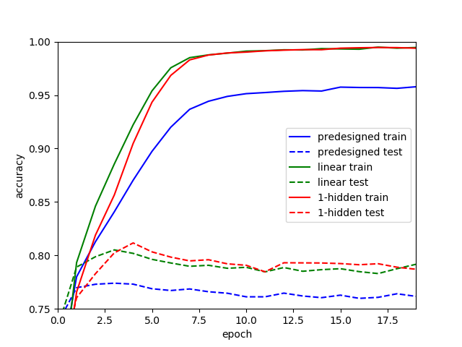In this experiment, the mixture of experts is a mixture of a linear expert and a convolutional expert. We want to see if simpler (mnist) images can be directed to linear experts and more complex (cifar) images can be directed to convolutional expert. From both accuracy (Figure 24) and activation (Figure 25), we could see that the convolutional expert is handling images from both datasets.

Figure . Accuracy on heterogeneous experts with different gates. Blue is the pre-designed gate, green is the linear gate, red is 1-hidden-layer gate. Solid line is on train data, dashed line on test data.

|  |  |  |  |
| --- | --- | --- | --- |
| Model |  | Linear Expert | Convolutional Expert |
| Linear gate | Mnist | 0.00 | 1.00 |
|  | Cifar | 0.00 | 1.00 |
| 1-hidden layer gate | Mnist | 0.00 | 1.00 |
|  | Cifar | 0.00 | 1.00 |

Figure . Super-label activation table on heterogeneous experts.

1. MoE applications

(No changes here. I did not have enough time to look for more modern applications after the discussion 2 weeks ago)

Most of MoE-applications are related to time series mentioned in (Waterhouse, 1998). This includes control tasks with reinforcement learning, time series prediction and neural translation. As far as I understood, those tasks are related to capturing switching temporal patterns. Then the gating network tries to predict which temporal pattern is and the experts try to behave as they are in currently in the temporal pattern.

To capture temporal patterns and switch between them, MoE should be applied on every step, and gating receives input of current step and previous hidden state. In visual tasks, this kind of architecture might be more expensive then CNN. This also might be able to be generalized in the graph network framework. In tasks with only general features, the steps and the pattern between steps are undefined, and applying MoE per step would not be helpful.

Just one example of temporal patterns. Consider we have a computer generating series of numbers. In a period, it generates numbers by a rule (for example sin(x)) with noise. Later, the rule switched to another one (for example a series of zigzag) and continue to generate numbers during another period. This, with an alternative generating and switching rules, is a toy case of (Weigend;Mangeas;& Srivastava, 1995).

“Temporal patterns” mean here the rules generating the series in given periods. Gating network tries to predict if it is currently zigzag or sin(x). In some cases, the period is not decided randomly, but there could be some long-term trigger to be captured by hidden state, and temporal patterns are more complex. MoE should also be useful in this case.

# Bibliography

Waterhouse, S. R. (1998). *Classification and Regression using Mixtures of Experts.*

Weigend, A. S., Mangeas, M., & Srivastava, A. N. (1995). *Nonlinear gated experts for time series:.*